21. ECB, CBC and CFB modes + padding motivation
#include <stdio.h>

#define BS 8

void xor(int *a, int *b, int *r) {
for(int i=0;i<BS;i++)
r[i] = a[i] ^ b[i];
}

void encrypt(int *in, int *key, int *out) {
for(int i=0;i<BS;i++)
out[i] = in[i] ^ key[i];
}

void decrypt(int *in, int *key, int *out) {
for(int i=0;i<BS;i++)
out[i] = in[i] ^ key[i];
}

void print(int *x) {
for(int i=0;i<BS;i++) printf("%d",x[i]);
printf("\n");
}

int main() {
int p[BS], key[BS], iv[BS], temp[BS], c[BS];

printf("Enter 8-bit plaintext: ");
for(int i=0;i<BS;i++) scanf("%1d",&p[i]);
printf("Enter 8-bit key: ");
for(int i=0;i<BS;i++) scanf("%1d",&key[i]);
printf("Enter 8-bit IV: ");
for(int i=0;i<BS;i++) scanf("%1d",&iv[i]);
encrypt(p,key,c);
printf("ECB: ");
print(c);
xor(p,iv,temp);
encrypt(temp,key,c);
printf("CBC: ");
print(c);
/* CFB */
encrypt(iv,key,temp);
xor(p,temp,c);
printf("CFB: ");
print(c);

return 0;
}
Output
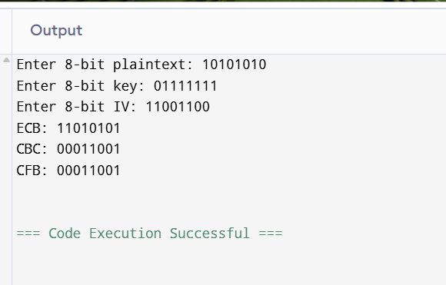

22. CBC Encryption and Decryption using S-DES
#include <stdio.h>

int sdes(int x, int key) {
/* Simplified S-DES style XOR cipher for CBC demonstration */
return x ^ (key & 255);
}

int main() {
int p[2] = {0x01, 0x23};
int c[2], d[2];
int iv = 0xAA;
int key = 0xFD;

/* CBC Encryption */
c[0] = sdes(p[0] ^ iv, key);
c[1] = sdes(p[1] ^ c[0], key);

printf("Ciphertext: %02X %02X\n", c[0], c[1]);

/* CBC Decryption */
d[0] = sdes(c[0], key) ^ iv;
d[1] = sdes(c[1], key) ^ c[0];

printf("Decrypted: %02X %02X\n", d[0], d[1]);

return 0;
}
Output
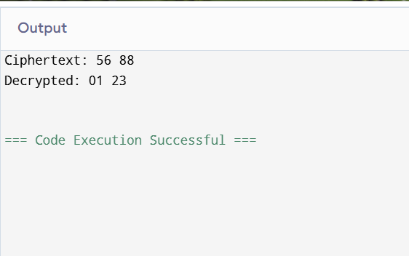

23 Counter Mode using S-DES
#include <stdio.h>

int sdes(int x, int key) {
return x ^ (key & 255);
}

int main() {
int p[3] = {0x01, 0x02, 0x04};
int c[3];
int counter = 0;
int key = 0xFD;

for(int i=0;i<3;i++) {
c[i] = p[i] ^ sdes(counter++, key);
}

printf("Ciphertext: ");
for(int i=0;i<3;i++)
printf("%02X ",c[i]);

printf("\n");

printf("Decrypted: ");
counter = 0;
for(int i=0;i<3;i++)
printf("%02X ", c[i] ^ sdes(counter++,key));

return 0;
}
Output
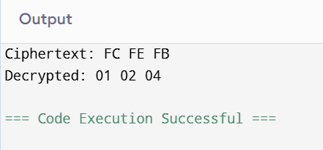
24. RSA Private Key
#include <stdio.h>

int main() {
int p = 59, q = 61;
int e = 31;
int phi = (p-1)*(q-1);
int d;

for(d=1; d<phi; d++) {
if((e*d)%phi == 1)
break;
}

printf("p = %d\nq = %d\n",p,q);
printf("phi(n) = %d\n",phi);
printf("Private key d = %d\n",d);

return 0;
}
Outpot
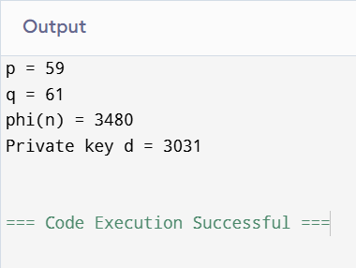
25. RSA plaintext block has a common factor with n
#include <stdio.h>

int gcd(int a,int b) {
while(b) {
int t=a%b;
a=b;
b=t;
}
return a;
}

int main() {
int n,m,g;

printf("Enter n: ");
scanf("%d",&n);

printf("Enter plaintext block: ");
scanf("%d",&m);

g = gcd(m,n);

if(g > 1)
printf("Factor found = %d\nRSA modulus can be factored.\n",g);
else
printf("No factor found.\n");

return 0;
}
Output
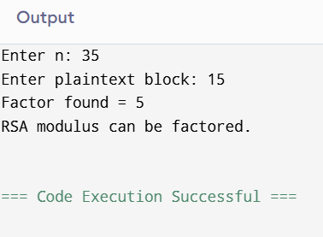
26. Bob leaks his RSA private key
#include <stdio.h>

int main() {
int p,q,n,e,d;

printf("Enter new prime p: ");
scanf("%d",&p);

printf("Enter new prime q: ");
scanf("%d",&q);

printf("Enter new public key e: ");
scanf("%d",&e);

n = p*q;

for(d=1; d<(p-1)*(q-1); d++)
if((e*d)%((p-1)*(q-1)) == 1)
break;

printf("New modulus n = %d\n",n);
printf("New public key = (%d,%d)\n",e,n);
printf("New private key = (%d,%d)\n",d,n);

return 0;
}
Output
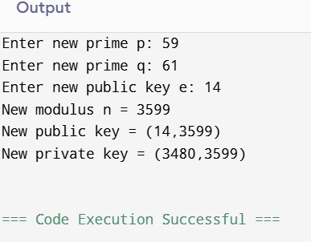
27. RSA encrypting each alphabetic character separately
#include <stdio.h>

long long power(long long a,long long e,long long n) {
long long r=1;
while(e--) r=(r*a)%n;
return r;
}

int main() {
long long n,e,c;

printf("Enter n and e: ");
scanf("%lld%lld",&n,&e);

printf("Enter ciphertext: ");
scanf("%lld",&c);

for(int m=0;m<26;m++) {
if(power(m,e,n)==c) {
printf("Plaintext character = %c\n",'A'+m);
return 0;
}
}

printf("Character not found.\n");
return 0;
}
Output
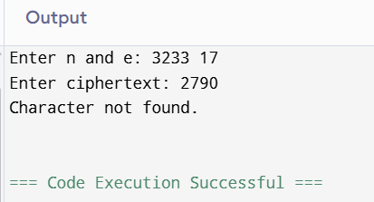
28. Diffie-Hellman protocol

#include <stdio.h>

long long power(long long a,long long b,long long q) {
long long r=1;
while(b--) r=(r*a)%q;
return r;
}

int main() {
long long a,q,x,y,A,B,K1,K2;

printf("Enter public a and q: ");
scanf("%lld%lld",&a,&q);

printf("Enter Alice secret x: ");
scanf("%lld",&x);

printf("Enter Bob secret y: ");
scanf("%lld",&y);

A = power(a,x,q);
B = power(a,y,q);

K1 = power(B,x,q);
K2 = power(A,y,q);

printf("Alice public key = %lld\n",A);
printf("Bob public key = %lld\n",B);
printf("Alice shared key = %lld\n",K1);
printf("Bob shared key = %lld\n",K2);

return 0;
}
Output
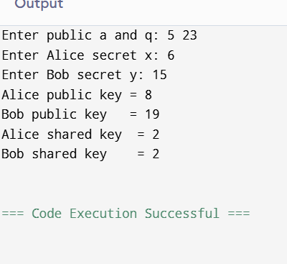

29. SHA-3 — 1024-bit block
#include <stdio.h>

int main() {
int block = 1024;
int lane = 64;
int message_lanes, capacity_lanes;

message_lanes = block / lane;
capacity_lanes = 25 - message_lanes;

printf("Block size = %d bits\n", block);
printf("Lane size = %d bits\n", lane);
printf("Message lanes = %d\n", message_lanes);
printf("Initial zero capacity lanes = %d\n", capacity_lanes);

printf("\nAfter processing first block:\n");
printf("Nonzero message lanes = %d\n", message_lanes);
printf("Zero capacity lanes = %d\n", capacity_lanes);

return 0;
}
Output
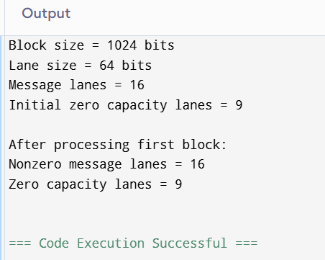

30. CBC-MAC Attack
#include <stdio.h>

int main() {
int X, T, Y, MAC;

printf("Enter message block X: ");
scanf("%d", &X);

printf("Enter CBC-MAC T: ");
scanf("%d", &T);

Y = X ^ T;

printf("\nOriginal message X = %d", X);
printf("\nOriginal MAC T = %d", T);
printf("\nSecond block (X XOR T) = %d", Y);

MAC = T;

printf("\nCBC-MAC of X || (X XOR T) = %d\n", MAC);

return 0;
}
Output
